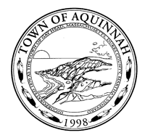

**Town of Aquinnah Notice of Public Meeting**

**Gay Head Lighthouse Advisory Board** 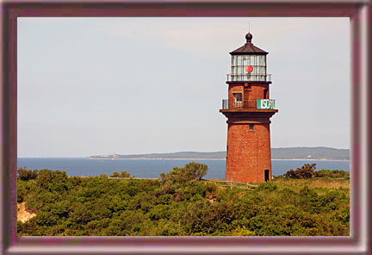

**Will hold a meeting on Monday, April 29th, 2019 at 4:30pm in the Aquinnah Town Offices**

I) Old Business

1. Review of minutes from the 3/25 meeting

  2. Review of Accounts

3. Lighthouse & Park report

4. Restoration update

a. Schedule for roof restoration work

5. Fund Raising / Grants

a) Mitigation proposal from Vineyard Wind

b) Bond Bill update.

II) New Business

1. Meet with Deborah Medders to discuss shed design
2. Pedestrian Guardrail update

III) Other Business

IV) Adjourn

Posted 4 /25 /19