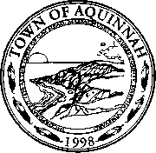

**Meeting of the Aquinnah Conservation Committee**

Sarah Thulin

Steve Yaffe

Mary Elizabeth Pratt

Sibel Suman

Kathy Newman

AQUINNAH CONSERVATION COMMISSION

On June 25, 2019 at 4 PM a public hearing will be held in the Aquinnah town offices under the Town of Aquinnah Wetlands Water Resource Bylaw to act on a Request for Determination of Applicability filed by the Steinberg Family Limited Partnership for the removal and reconstruction of an existing house and the relocation of an existing driveway within the buffer zone of a bordering vegetated wetland.

Location: 264 Lighthouse Rd. Map 5 Parcel 215 Site Visit: June 25, 2019 at 3:35 PM